**Player Profile Dashboard**

*Project with Ludis Analytics*

**Summary**

In an effort to help NCAA men’s basketball coaches, scouts, and players draw meaningful insights for making data-driven decisions, this project involved the creation of an app that would display important visualizations and breakdowns of key statistics. Overall, the app houses data for over 8,000 NCAA across 4 seasons, allowing users to access important patterns and trends in play.

The application was created in RStudio as a Shiny Web Application. Code for the creation of the app can be viewed in the appendix.

**Important Features of the App**

In the app, there are several toggles that allow different views of the data (Figure 1). First, the user selects a player and season. Next, the user can specify one of three views for the main visualization: Heat Map, Scatter Chart, or Hex Chart. These visualizations help display what a player’s overall trends are on offense including where most of their important plays come from and where on the court they are most successful.

The final toggle the user can select is a view for the boxscore: General, Offensive, or Defensive. These options will change the view of the chart on the bottom, allowing the user to see typical box score statistics coupled with advanced stats such as where a player ranks in a certain statistics among other NCAA players of their same position.

*Figure 1 – Available Feature Selections for the App*

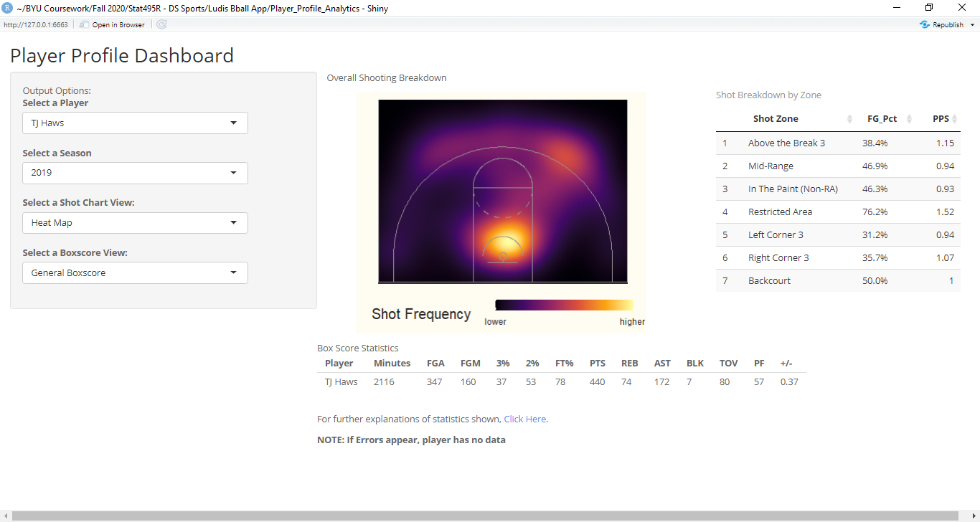

**Analyses Available**

For the main visualization in the app, users can see either the heat map, scatter chart, or hex chart in order to better analyze a player’s offensive performance. Each of these views provide different insight for where a player tends to perform best. This may also allow coaching staff to help adequately prepare their players for an opponent by seeing where a player also tends to be the weakest offensively (Figure 2).

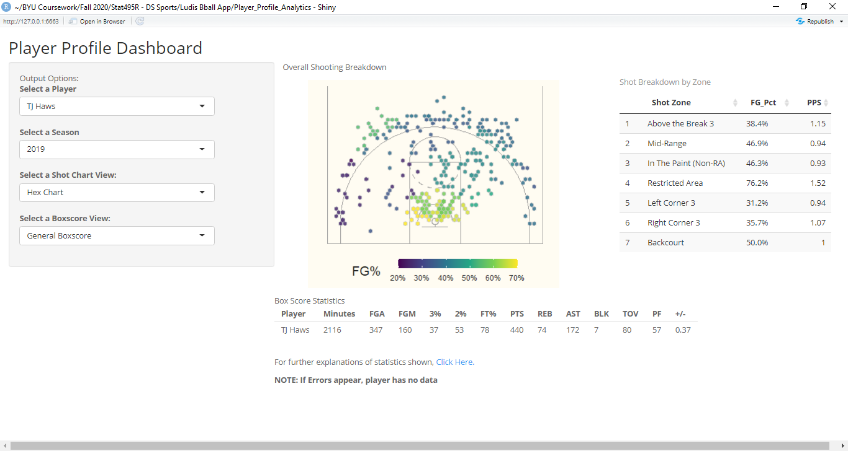*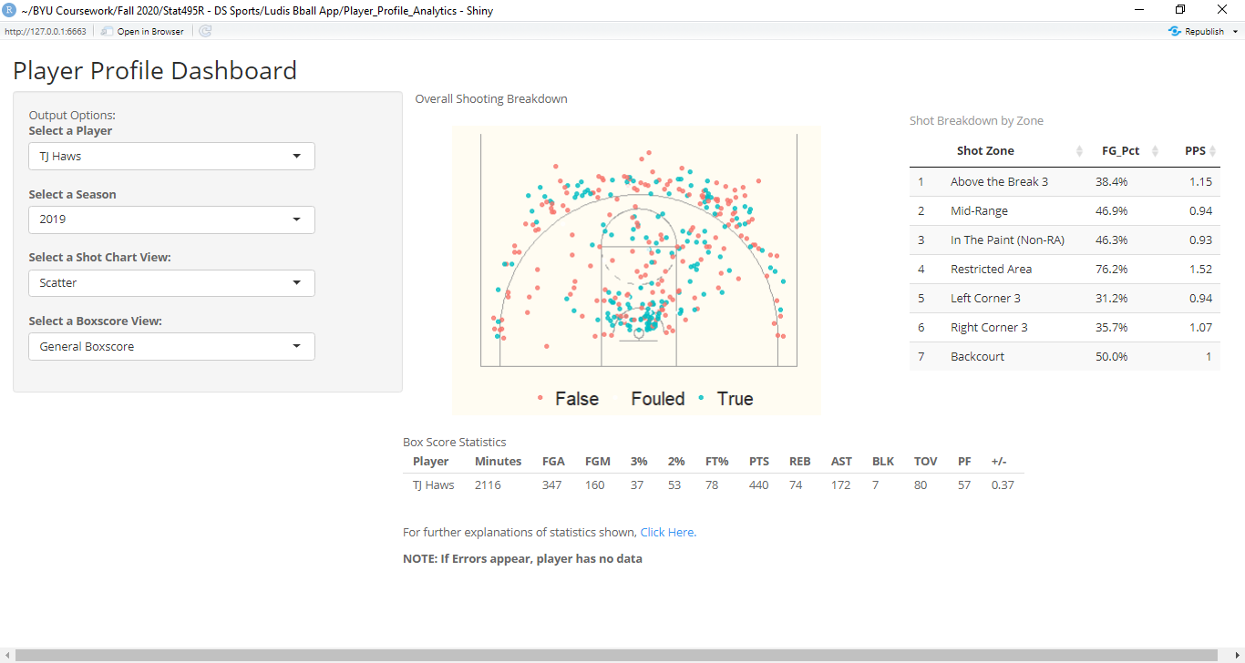**Figure 2 – Available Views for Offensive Breakdown*

Next, the user is also able to view a player’s shooting breakdown by zone on the court, including their field goal percentage and points per shot attempt (Figure 3). By selecting the arrows at the top of each column, the values will be sorted by that value. This allows for better understanding of performance by location, supplemented by the overall visual selected.

*Figure 3: View of Shooting Breakdown for Select Player*



Finally, as mentioned before the user will have the option to view three different box score breakdowns of key statistics for the selected player (Figure 4). These range from general, overall, and defensive views. Of particular mention is the ability in the offensive and defensive views to see how a player stacks up against other players in their league. For example, in the offensive view there is the ability to see “TS_PERC”, which is the percentile ranking for that player for true shooting percentage among other NCAA players of their same position.

*Figure 4 – Available Box Score Views for Selected Player*

**General View**



**Offense View**

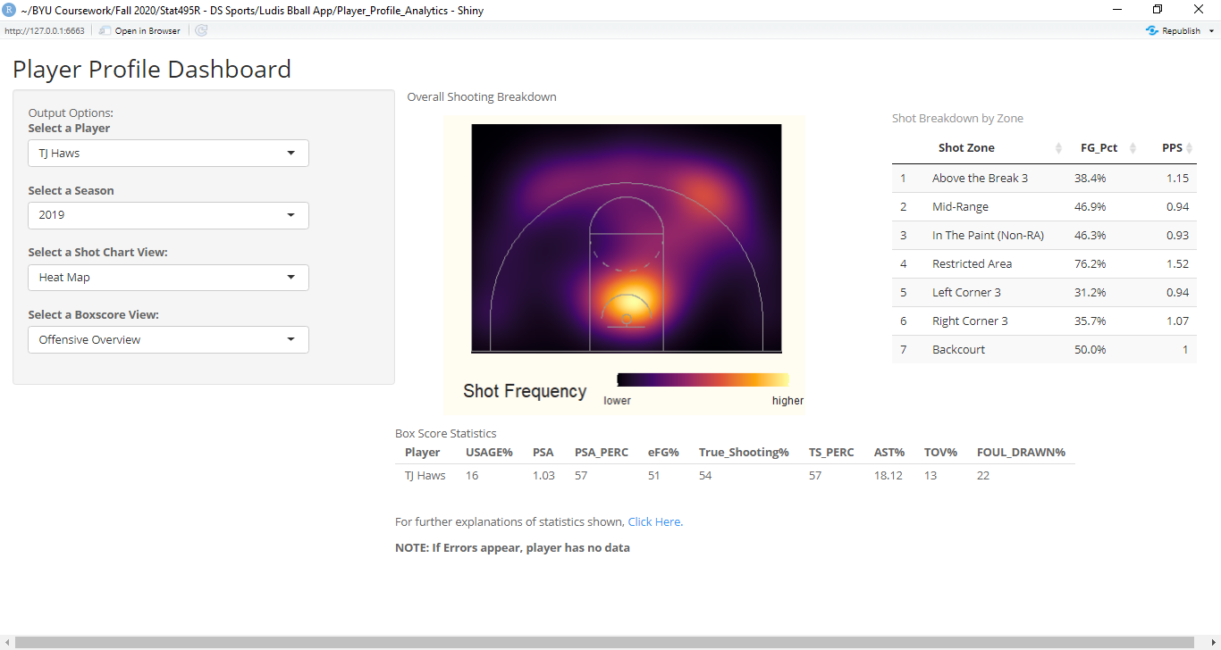

**Defense View**

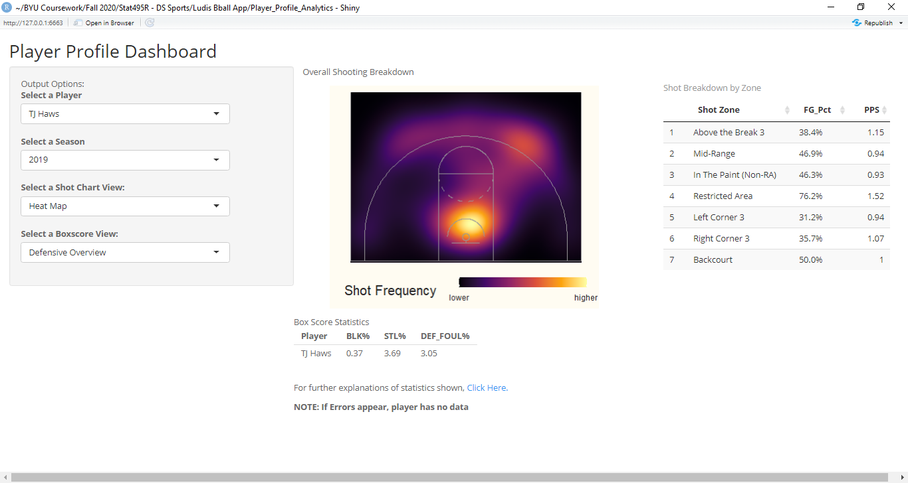

**All Together**

Below are a few examples of the overall view of the app for a selected player and season (Figure 5). Full functionality of the app can be viewed at rsconnect.byu.edu.

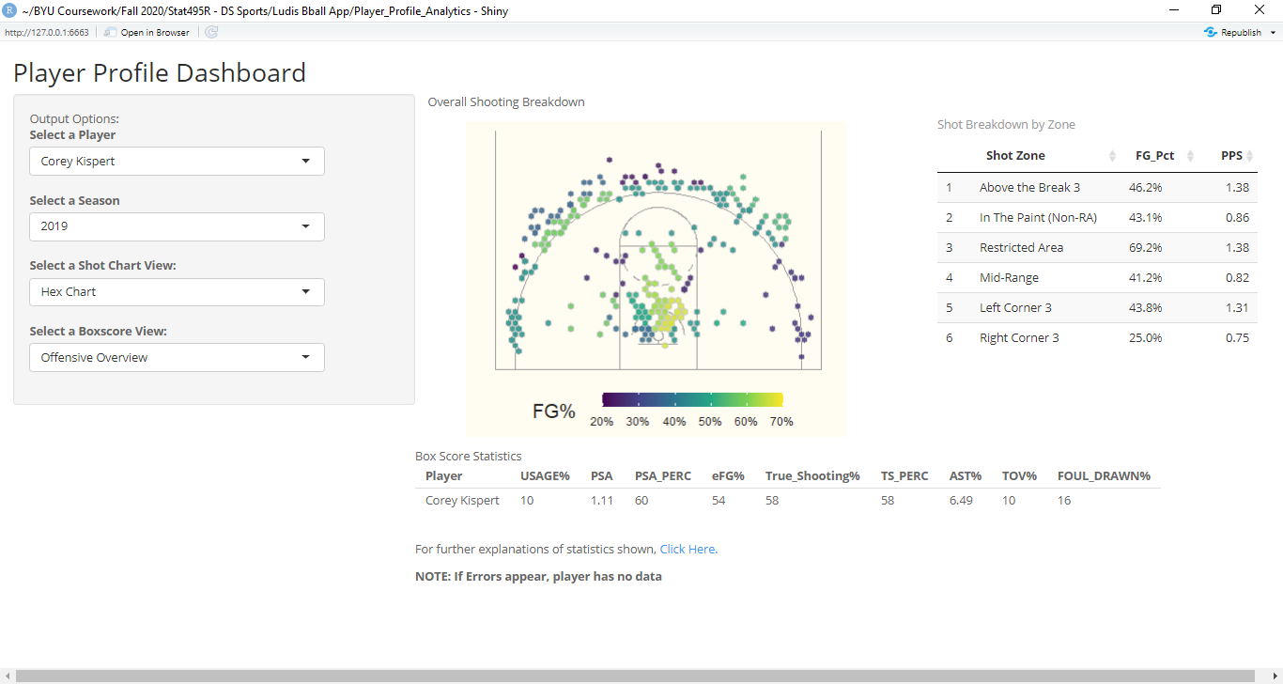***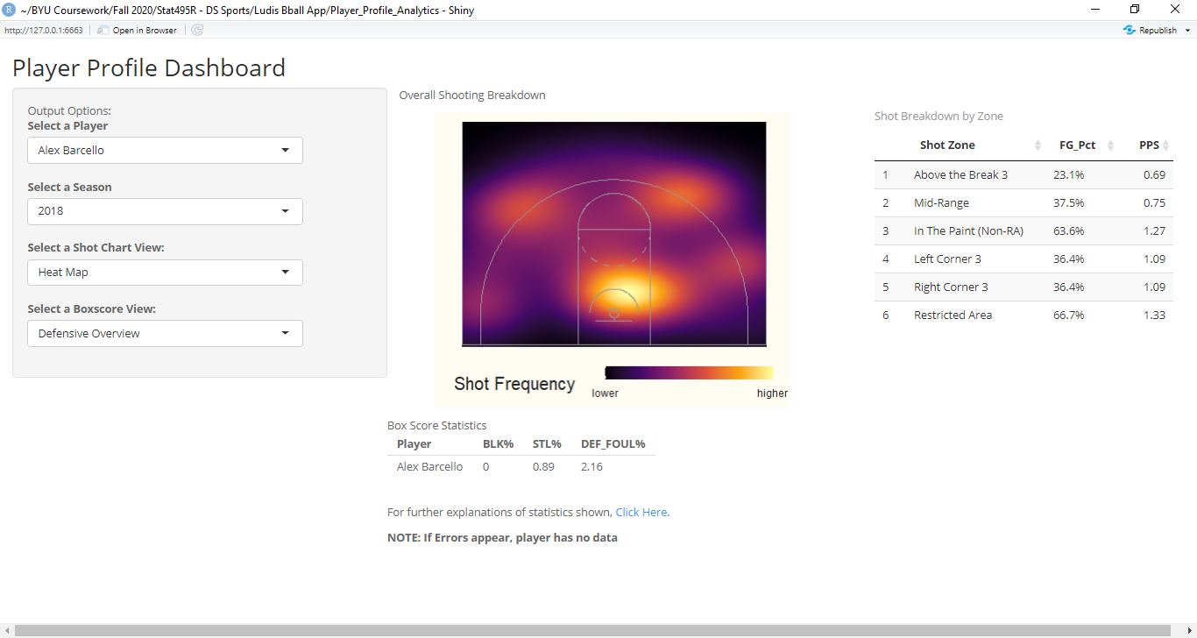Figure 5 – Overall Views of the App***